|  |
| --- |
| Queen Mary University of London |
| Life Cycle Assessment on Laptop Batteries |
| EMS622U – Sustainability Assessments for Design |

|  |
| --- |
| Awais Amjad  19/05/2024 |

**Introduction**

In today's technological landscape, Lithium-Ion batteries (LIBs) play a pivotal role in powering laptops, boasting higher energy density and lower weight compared to previous batteries [1]. Their widespread adoption is evident in the global LIB laptop market, valued at $54.6 billion [2]. However, this growth brings challenges such as increased waste in landfills and harmful emissions such as CO2 being released into the atmosphere. Estimates suggest between 200 million and 500 million tons of battery waste are generated annually as of 2020 [3]. As someone deeply interested in technology and actively involved in a project aimed at reducing electronic waste, this Life Cycle Assessment (LCA) will be a crucial asset and will provide a comprehensive understanding of the impacts associated with LIBs.

This LCA aims to evaluate the environmental, economic, and social impact of laptop LIBs and identifying areas for potential improvement. To provide context, Nickel Cadmium batteries (NiCadB), the pioneers of laptop batteries [4] will serve as a comparator product, enabling a comparison of sustainability improvements over time.

# I will discuss the life cycle of LIBs and NiCadBs, defining the functional unit for comparison. An environmental assessment will evaluate key indicators using summarised inventory data, which will be displayed and discussed, with a critique of data accuracy. This process will be repeated for economic and social assessments. The discussion section will address study limitations and suggest improvements to the process and product, including material changes. Finally, the conclusion will offer recommendations for further improvement.

# **Life Cycle and Scope**

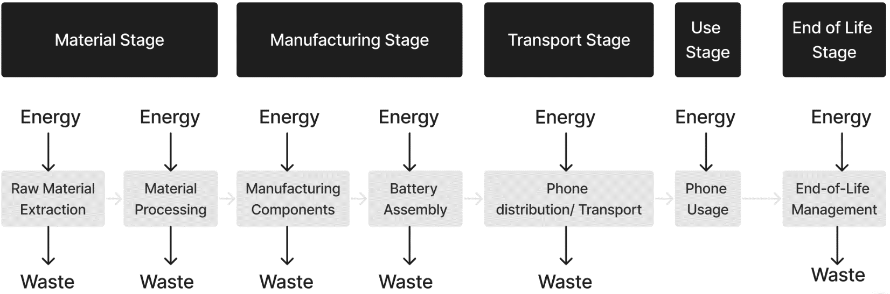

All stages are considered in this LCA.

**Functional Unit**

It was necessary to establish specific assumptions regarding a battery’s characteristics for precision and given the variability in factors like weight and power rating across different battery types, these variables were standardised for both LIBs and NiCadBs. These assumptions were informed by thorough research on various battery types [13, 14, 15]. This leads my functional unit to be **1000 laptop batteries that provide 5,000** **mAh of capacity, with a voltage of 3.7 volts, over a service life of 5 years, with 200 days of daily use per year**. Additional considerations were a weight of **650 grams**. These assumptions were factored into the Eco Audit conducted later in the paper where explanations for the assumptions are stated.

**Battery Components and Materials**

Appendix A provides an explanation of how the batteries operate, shedding light to the components. Variations in component materials lead to distinct environmental effects, highlighting the significance of analysing each component. To streamline this process, common materials utilised in various battery parts have been carefully selected for inclusion in this LCA, ensuring a comprehensive assessment and alternative material types will be omitted.

|  |  |  |  |  |
| --- | --- | --- | --- | --- |
| **Battery Component** | **LIB** | **Weight Makeup (%)** | **NiCadB** | **Weight Makeup (%)** *Relative to LIB due to limited data* |
| **Anode** | Lithium carbonate such as graphite [5] | 10 – 20 Assumption for calculations: 15 [32] | Nickel Oxide Hydroxide (NiOOH) [4] | 10 – 20 Assumption for calculations: 15 |
| **Cathode** | Lithium Cobalt Oxide (LiCoO2) [6] | 30 – 40 Assumption for calculations: 35 [33] | Cadmium [4] | 30 – 40 Assumption for calculations: 35 |
| **Electrolyte** | Lithium hexafluorophosphate (LiPF6) [7] | 5 – 15  Assumption for calculations: 6  [34] | Consists of a potassium hydroxide (KOH) solution [4] | 10 – 30 Assumption for calculations: 15 |
| **Casing** | Nickel coated steel [11] | 30 – 40 Assumption for calculations: 30 | Steel, Nylon, Propylene [9] Assumptions for Calculations: Steel | 20 – 30 Assumption for calculations: 21 |
| **Anode Current Collector** | Copper [10] | 2 – 6 Assumption for calculations: 6  [34] | Nickel [14] | 2 – 6Assumed: 6 |
| **Cathode Current Collector** | Aluminium [10] | 2 – 6 Assumption for calculations: 6  [34] | Nickel [8] | 2 – 6 Assumed: 6 |
| **Separator** | Polyethylene [11] | 1 – 2 Assumption for calculations: 2 [32] | Polyamide [12] | 1 – 2 Assumed: 2 |

Battery Component Data Table

# The absence of data regarding the material weight makeup of NiCadBs required an assumption that it mirrored that of LIBs. This approximation was made to establish a baseline for comparison between the batteries, particularly in terms of materials and associated costs. However, this approach has limitations, as significant differences in weight makeup could distort the results, leading to inaccuracies. To address this issue, real-life battery information, including costs and alternative uses, is incorporated into the assessment, mitigating discrepancies, and ensuring reliability.

## **Environmental Assessment**

## **Indicators**

|  |  |  |
| --- | --- | --- |
| **Indicators** | **Unit** | **Reasoning** |
| Water Consumption | m3 | A finite resource essential for various stages of battery production, including raw material extraction and processing. High water consumption can lead to depletion of local water sources, ecosystem degradation, and conflicts over water access. [20] |
| CO2 Emissions | kg | CO2 emissions are a primary contributor to climate change and global warming. Battery production and usage generate CO2 emissions through energy-intensive processes, such as mining, refining, manufacturing, and transportation. Monitoring CO2 emissions allows us to quantify the carbon footprint of different battery technologies and assess their contribution to climate change. [21] |
| Energy Usage | MJ | Energy usage is intricately linked to CO2 emissions and resource depletion, as it reflects the amount of energy required to extract, process, and manufacture battery materials as well as during the usage of the laptops. High energy usage not only contributes to CO2 emissions but also increases the demand for fossil fuels and other finite energy resources. [22] |
| Toxicity | N/A | Exposure to toxic substances can have adverse effects on human health, wildlife, and ecosystems, leading to pollution, contamination, and long-term environmental damage. [21] |

## **Data Sources**

The primary data source utilised for this Economic Assessment was EduPack [23], a software tool designed for materials education and selection. EduPack emerged as an optimal choice for this evaluation due to its vast repository of materials and properties, fundamental for conducting effective LCAs. Incorporating an Eco Audit tool, it can facilitate the identification of CO2 Emissions and Energy Usage hotspots throughout the product life cycle. EduPack's ability to integrate rechargeable LIBs and NiCadBs into the audit process provided valuable insights. Notably, LIB data was sourced from laptop batteries, while the origin of NiCadB data remained unknown. Despite some limitations, such as data presented in range formats and unavailable materials like LiPF6, EduPack remained an invaluable resource for comprehensive data acquisition. In addition to EduPack, supplementary data sources were consulted, including manufacturer data sheets and updates from the battery industry. Extensive fact-checking was conducted to ensure accuracy, albeit acknowledging the potential risk of misinformation. In any instances where data was lacking, engineering-based assumptions were made, or the absence of information was explicitly stated. While reducing data robustness, this process enabled the derivation of suitable results and conclusions for the assessment.

# **Eco Audit**

An Eco Audit of LIBs and NiCadBs was conducted to assess CO2 Emissions and Energy Usage throughout the life cycle. The assumptions applied to both devices can be seen in the table below.

|  |  |  |
| --- | --- | --- |
| **Assumption** | **Factor** | **Value** |
| **Equal** | Weight | 650 grams |
| **Equal** | Years of Use | 5 |
| **Equal** | Days of Use | 200 |
| **Equal** | Hours of Use | 6 |
| **Equal** | Capacity | 5000 mAh |
| **Equal** | Voltage | 3.7 volts |

The purpose of making these assumptions was to isolate the impact of materials and their quantities throughout the life cycle stages. The data was sourced from EduPack, which provided electronic component data. For my analysis, I selected the Li-Ion rechargeable battery (for laptops) as the primary product and Ni-Cd rechargeable batteries as my comparison product. This choice was made due to the unavailability of Ni-Cd data specifically for laptops. It is important to note that the data obtained cannot be considered a precise reflection of the battery component data table which relies on assumptions, while the EduPack database contains its own set of materials and compositions, albeit without clear indications of their usage contexts. Furthermore, the Eco Audit did not provide information for the Manufacture and Disposal stages which was therefore not assessed. However, based on the results for other stages and the data available in the inventory, it can be safely assumed that LIBs would generate more CO2 and consume more energy than NiCadBs in these stages. This assumption is grounded in the higher production complexity and material requirements of LIBs compared to NiCadBs.

For transport considerations, the following journey was assumed. Lithium, mined in Chile, is transported to China for refinement and battery production [24, 25]. Subsequently, the batteries are shipped to the UK for use. In the case of nickel-cadmium, since cadmium is a byproduct of zinc processing, which primarily occurs in China [16], the batteries are manufactured in China and then sent to and used in the UK.

**Inventory**

|  |  |  |  |  |
| --- | --- | --- | --- | --- |
|  | **LIB** | | **NiCadB** | |
| **Stage** | **CO2 Footprint (kg)** | **Energy Usage**  **(MJ)** | **CO2 Footprint**  **(kg)** | **Energy Usage**  **(MJ)** |
| **Material** | 50,481 | 525,534 | 4,932 | 52,109 |
| **Manufacture** | N/A | N/A | N/A | N/A |
| **Transport** | 5,124 | 57,109 | 2,147 | 18,972 |
| **Use** | 9,238 | 624,786 | 987 | 21,470 |
| **Disposal** | N/A | N/A | N/A | N/A |
| **End of Life (EoL) potential** | -51,940 | -612,256 | -3066 | -53,859 |

CO2 Emissions and Energy Usage Table

|  |  |  |
| --- | --- | --- |
| **Hazard Rating** | **Lithium** | **Cadmium** |
| **Health** | 3 | 4 |
| **Flammability** | 2 | 3 |
| **Reactivity** | 2 | 1 |

Hazard Rating of Materials Table [18,19]

*Hazard Rating Key: 0=minimal; 1=slight; 2=moderate; 3=serious; 4=severe*

|  |  |  |
| --- | --- | --- |
| **Battery Component** | **LIB** | **NiCad** |
| **Anode** | Graphite - Non-poisonous | Nickel Oxide Hydroxide (NiOOH) |
| **Cathode** | Lithium Cobalt Oxide (LiCoO2) - poses significant health risks when inhaled or ingested in excessive amounts. Exposure can lead to chronic respiratory and cardiovascular issues, as well as reproductive system complications in both genders. Those involved in cobalt mining and processing face the highest risk. | Cadmium - poses significant health risks. Ingestion or inhalation of cadmium compounds can lead to severe respiratory issues and long-term health problems, including kidney damage and cancer. |
| **Electrolyte** | LiPF6 – can impact the digestive, circulatory, respiratory, and nervous systems, as well as the skin and bones. Ingestion poses the highest risk, but inhalation and skin contact can also cause harm. | Potassium hydroxide (KOH) solution - Exposure to battery electrolytes can cause serious harm. Contact can corrode eye tissues, potentially leading to blindness, while skin exposure may result in severe burns. Ingestion can damage throat tissues, and the presence of cadmium and nickel compounds poses carcinogenic risks. |
| **Casing** | Nickel coated steel – Coal-fired nickel smelters emit carcinogenic sulphur dioxide into the air, leading to deformities and respiratory issues linked to pollution exposure. | typically made from metal or plastic materials and houses the internal components, including the positive and negative electrodes, electrolytes, and separators. |
| **Anode Current Collector** | Copper – Non-poisonous | Nickel – *Check previous* |
| **Cathode Current Collector** | Aluminium – can be a major threat to humans, animals, and plants | Nickel – *Check previous* |
| **Separator** | Polyethylene – Non-Hazardous | Polyamide – Non-poisonous |

Toxicity of Components Table [26, 27, 28, 29]

|  |  |  |
| --- | --- | --- |
| **Part** | **Material** | **Water Consumption (m3) per Functional Unit** |
| Casing | Nickel Coated Steel | 0.2 – 20 |
| Anode | Graphite | *Negligible* |
| Lithium parts – Cathode and Electrolyte | LiCoO2  LiPF6 | 3.78 - 4.88  *Majority of the water consumption comes from the lithium so any other materials will not be considered* |
| Current Collectors | Copper  Aluminium | 0.078 |
| Separator | Polyethylene | *Negligible* |
| **Total** |  | **4.058 - 24.958** |

LIB Water Consumption Table – Material Stage

|  |  |  |
| --- | --- | --- |
| **Part** | **Material** | **Water Consumption (m3) per Functional Unit** |
| Casing | Steel | 0.2 - 20 |
| Anode | NiOOH | 2.8 |
| Cathode | Cadmium | 1.72 - 1.96  *As the Material stage is the Manufacturing stage due to how Cadmium is produced it will have half of the water consumption for this stage and the rest will be considered in the Manufacturing stage* |
| Electrolyte | KOH | 1.24 |
| Current Collectors | Nickel | 0.42 - 0.48 |
| Separator | Polyamide | *Negligible* |
| **Total** |  | **6.42 - 26.48** |

NiCadB Water Consumption Table – Material Stage

|  |  |  |
| --- | --- | --- |
| **Part** | **Material** | **Water Consumption (m3) per Functional Unit** |
| Casing | Nickel Coated Steel | 0.1 – 17 |
| Anode | Graphite | *Negligible* |
| Lithium parts – Cathode and Electrolyte | LiCoO2  LiPF6 | 2.43 - 3.92  *Majority of the water consumption comes from the lithium so any other materials will not be considered* |
| Current Collectors | Copper  Aluminium | 0.058 |
| Separator | Polyethylene | *Negligible* |
| **Total** |  | **2.588 - 20.978** |

LIB Water Consumption Table – Manufacturing Stage

|  |  |  |
| --- | --- | --- |
| **Part** | **Material** | **Water Consumption (m3) per Functional Unit** |
| Casing | Steel | 0.16 - 16.6 |
| Anode | NiOOH | 2.84 |
| Cathode | Cadmium | 1.24 - 1.37  *As the Manufacturing stage is the Material stage due to how Cadmium is produced it will have half of the water consumption for this stage and all will be considered in the Material stage* |
| Electrolyte | KOH | 1.25 |
| Current Collectors | Nickel | 0.45 - 0.68 |
| Separator | Polyamide | *Negligible* |
| **Total** |  | **5.94 - 22.74** |

NiCadB Water Consumption Table – Manufacturing Stage

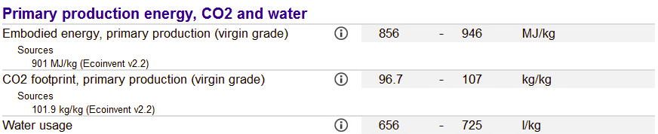

LIB Production Data

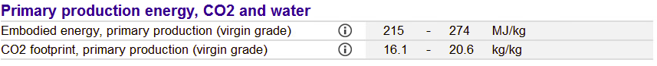

NiCadB Production Data

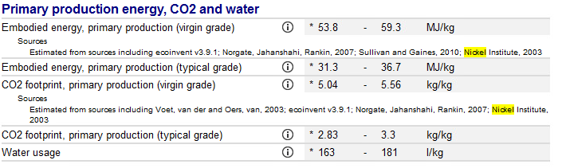

Steel Production Data

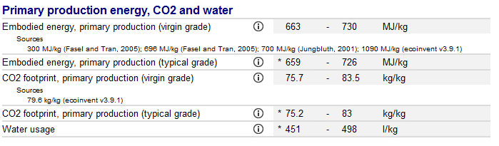

Lithium Production Data

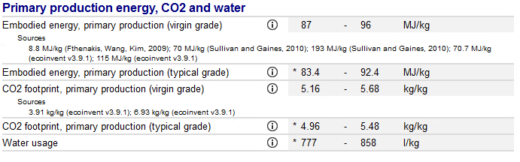

Cadmium Production Data

# **Results and Analysis**

## **CO2 Emissions and Energy Usage**

**Material Stage**

LIBs have a significantly larger CO2 footprint compared to NiCadBs across all stages of the life cycle. During the material stage, LIBs exhibit an extremely high CO2 footprint of 50,481 kg per functional unit which can be attributed to the energy-intensive processes involved in extracting and refining lithium, such as brine extraction and rock ore mining which create massive land deformations, where much of the energy used to extract and process it comes from CO2-emitting fossil fuels. The process can take up to years to complete, further increasing the release of harmful emissions [24]. In contrast, NiCadBs have a fraction of the CO2 footprint at 4,932 kg per functional unit during the material stage. This can be attributed to Cadmium, the main material for NiCadBs, which is often a byproduct of manufacturing processes for zinc and other materials [35]. As these processes are already being carried out, much of the effort and energy to produce cadmium is reduced therefore reducing its overall CO2 Emissions and Energy Usage during the material stage.

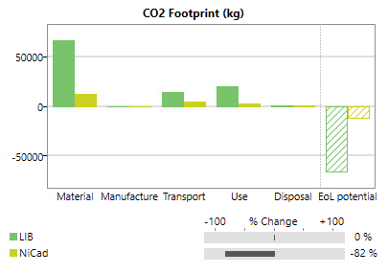 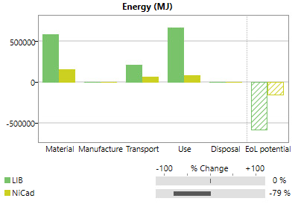

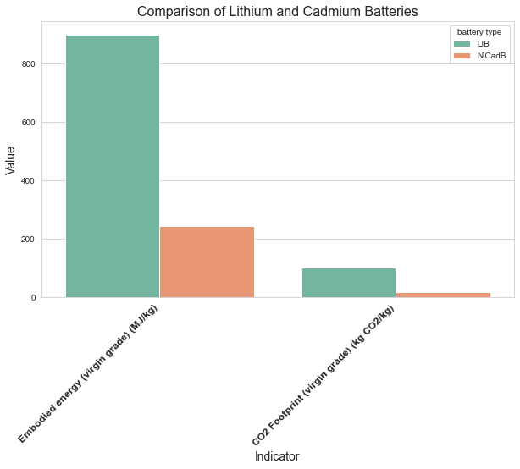

This can also be understood through the *Battery Component Data Table*, which shows that the anode, cathode, and casing constitute most of the battery's weight. These components are primarily composed of lithium, cadmium, and steel. Analysing the materials' production data reveals that steel and cadmium contribute only a fraction of the energy consumption and CO2 footprint compared to lithium. The data is measured per kilogram of material to ensure accuracy in comparison. The high footprint and energy usage for lithium align with the previously mentioned reasons.

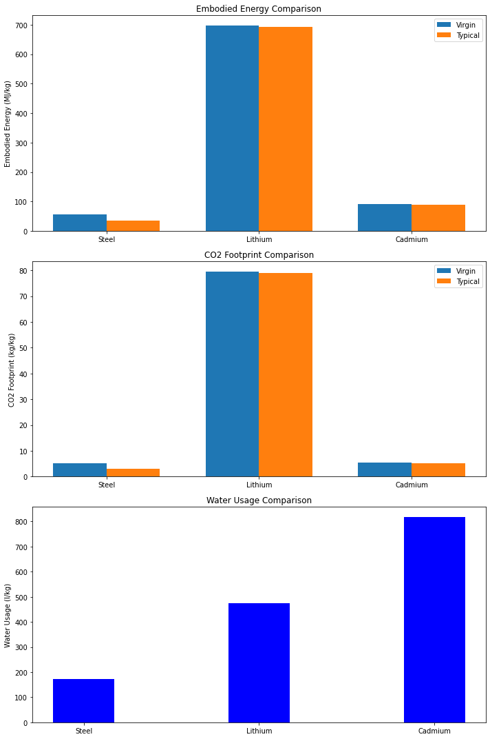

**Transport and Use Stage**

The Transport and Use stages also show that LIBs have a greater CO2 footprint than NiCadBs, although the differences are not as pronounced as in the material stage. The observed trend aligns with the current battery market landscape, where LIBs dominate and are expected to continue growing. This dominance is fuelled by the widespread adoption of LIBs in various applications such as electric vehicles, consumer electronics, and grid energy storage systems, driven by their higher energy density and longer lifespan. In contrast, NiCadBs have reached a plateau or even a decline in usage due to regulatory bans and environmental concerns associated with the toxicity of cadmium [17]. As LIBs continue to grow, we can expect its CO2 emissions and Energy Usage to further increase while we may see a sharp drop for NiCadBs.

**EoL Stage**

Regarding the EoL potential, the data suggests that LIBs typically have a much higher recycling potential compared to NiCadBs. This can be attributed to several factors:

1. **Availability**: LIBs are more widely used and available than NiCadBs, resulting in a larger supply for recycling processes.
2. **Material Composition**: LIBs contain valuable materials such as lithium, cobalt, and nickel, which can be efficiently recovered and reused in the production of new batteries or other applications, making their recycling more economically viable.
3. **Recycling Infrastructure**: There is a well-established and growing infrastructure for LIB recycling, with specialized facilities capable of extracting and purifying valuable materials from spent batteries, enabling a more efficient recycling process.

While NiCadBs have a lower environmental impact during their production and use stages, their lower recycling potential and the presence of toxic cadmium pose additional challenges for responsible end-of-life management.

This data, however, may be misrepresented to suggest that LIBs are more harmful across all stages of the life cycle than NiCadBs. However, as pointed out previously, this assessment fails to account for the current demand and use of the batteries. To gain a more accurate assessment, the value of each stage was measured accounting for the popularity of LIBs. Due to a lack of data, it is not possible to assess how many of each battery are made each year. Therefore, assuming equal battery cost and accounting for laptop battery share of the overall battery market ($7.5 billion of $123 billion [54]), we can assess the batteries based on their market share. Currently, LIBs hold a market share of $54.6 billion, while NiCad has $1.4 billion [2,25, 53].

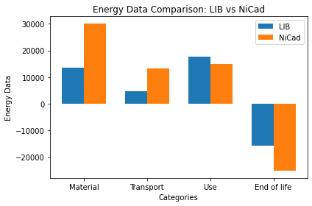 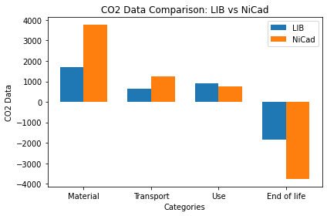

The analysis reveals that the Material and End-of-Life stages are significant hotspots for both batteries in terms of CO2 emissions and energy usage, while the Use stage is particularly notable for energy usage. The data somewhat aligns with current external sources, as lithium-ion batteries (LIBs) are lighter than nickel-cadmium batteries (NiCadBs), which can reduce CO2 emissions and energy usage during the Transport stage. Additionally, LIBs are more efficient, resulting in lower CO2 emissions and energy usage during the Use stage. LIBs are also easier to recycle and reuse, and their superior efficiency and compactness yield greater EoL potential. However, the data indicates that NiCadBs produce more CO2 and use more energy than LIBs in the Material stage, which may not be accurate as Lithium overall has higher CO2 Emissions than Cadmium. Overall, this assessment lacks slight robustness, as it assumes a linear relationship between market share and the number of batteries produced. Despite this, the results are adequately accurate and can be considered for further evaluation.

**Water consumption**

The Eco Audit tool lacked the functionality to assess water consumption at individual stages, necessitating the use of total water usage across the entire life cycle. Additionally, this data was only available for LIBs, with no information for NiCadBs. To address this data gap, a dedicated assessment of water consumption for both battery types was conducted, focusing on the Material and Manufacturing stages as the other stages would require minimal water or lacked data. This involved calculating water consumption for each component based on their respective weights and materials, using the *Battery Component Data Table* as a reference, as well as the processes used during the Manufacturing stage. The assessment revealed that for LIBs, most of the water consumption was due to the nickel-coated steel and lithium, while for NiCadBs, it was steel, NiOOH, and cadmium. These materials are primarily used in the casing, anode, and cathode (the anode for LIBs was negligible) which also constitute most of the battery's weight. This agrees with the data for CO2 emissions and energy usage, where similar patterns were observed. Other components were deemed negligible either due to minimal water usage during the extraction process or insufficient information available for assessment. Additionally, the process of coating nickel to steel was not considered. [23, 36, 37]

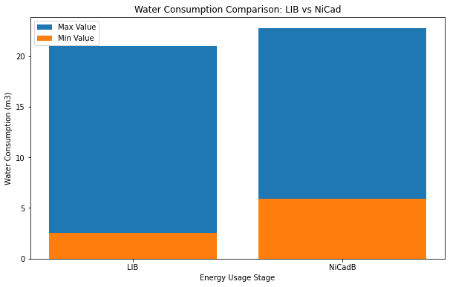 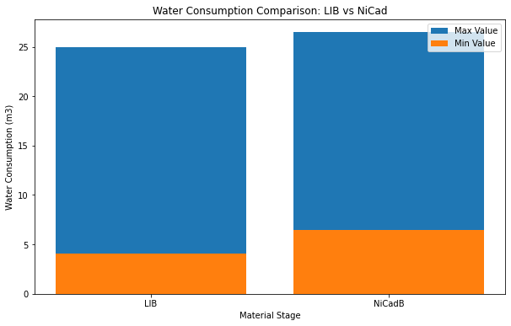

We can see that NiCadBs have a slightly higher Water Consumption across the Material and Manufacturing Stage than LIBs. This assessment lacks robustness as many assumptions were made for these calculations and resulted in minimal discrepancy between the batteries.

## Utilising the *Production Data* for the materials further shows that there may be miscalculations due to the assumptions from the water assessment as cadmium has a much higher water usage than lithium.

## **Toxicity**

To assess the toxicity of batteries effectively, it was essential to consider several factors such as the presence of toxic materials, their quantities, susceptibility to leakage, and their environmental impact. According to the **Hazard Rating of Materials Table**, both lithium and cadmium are assigned hazard ratings, indicating their potential risks to health and the environment. Cadmium, notably, receives a higher hazard rating, indicating greater damage to health and a higher susceptibility to flammability. In scenarios involving material leakage due to battery misuse, or disposal in landfills, cadmium presents a more significant toxic risk, as it can be inhaled or ingested. The hazard rating key, ranging from 0 (minimal) to 4 (severe), provides insights into the relative toxicity levels of lithium and cadmium.

Using the **Toxicity of Components Table**, we can examine the significant risks to both humans and animals from the materials. While the high-grade casings of these batteries typically prevent harm under normal conditions, there remains a substantial risk during manufacturing, processing, and end-of-life stages. Studies indicate that NiCadBs pose greater toxicity concerns due to cadmium and that the vast investments into lithium recycling mean more lithium is being reused and not mined. Combined with its longer life cycle, in terms of toxicity, lithium-ion batteries are less harmful than nickel-cadmium batteries. [26, 27, 28, 29]

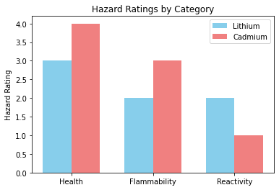

**Economic Assessment**

In this assessment, the manufacturing costs of the batteries and their components are analysed to determine which battery is more expensive and why. A detailed examination of the components and their costs is conducted, allowing for a discussion on the reasons behind the costs and potential improvements to reduce them. Following this, a hypothetical case study will be conducted, evaluating the batteries against four indicators to assess which battery is a better financial investment.

## **Indicators**

|  |  |  |  |
| --- | --- | --- | --- |
| Indicators | Units |  | Reasoning |
| Cost of Battery | £ | Examines the cost of the materials against their makeup of the battery to assess the cost of the battery. | The cost of manufacturing each battery type reveals insights into the efficiency of the production processes. A lower production cost indicates more efficient use of resources and better optimization of manufacturing techniques. |
| Cash Flow Analysis | £ | Examines the cash inflows and outflows of a company, detailing their sources, destinations, and amounts. [38] | Helps to understand the timing and magnitude of cash inflows and outflows of producing each type of battery. It can provide insights into if the company has enough cash to meet short-term requirements, whether the business is sustainable and can grow over time and aid in financial planning. |
| Return on Investment (ROI) | % | A profitability metric which is used to evaluate the performance of an investment. It is expressed as a percentage and calculated by dividing the net profit (or loss) by the initial cost or outlay [38] | ROI measures the profitability of the investment in battery production relative to its cost. It can help determine how effective the investment is in generating profits, allows for direct comparison between the returns of LIBs and NiCadBs and guide stakeholders into making informed decisions about allocating resources. |
| Net Present Value  (NPV) | £ | A financial metric that captures the total value of an investment by discounting all future cash inflows and outflows to the present day and then summing them. [38] | NPV calculates the present value of future cash flows generated by the battery production, discounted back to their value today. It helps to determine whether the project will add value to the company, if they are financially viable and assess the long-term profitability of the investment considering the time value of money. |
| Payback time | Years | The payback period is the length of time it takes to recover the cost of an investment or the length of time an investor needs to reach a breakeven point. [38] | Payback time indicates how long it will take to recover the initial investment from the cash flows generated by the battery production. It is useful to assess for financial risk, help in planning and managing cash flows and provide a quick estimate of how soon the project will start generating profits. |

## **Data Sources**

The primary data source for this economic assessment was EduPack. Gaps in EduPack were supplemented with financial statements from battery companies, articles, reports, and engineering assumptions. All data were thoroughly checked for accuracy and authenticity to ensure reliable calculations. However, due to some data gaps and the need for assumptions, the results may not fully reflect real-world accuracy.

**Inventory**

|  |  |  |  |  |
| --- | --- | --- | --- | --- |
| **Battery Component** | **LIB** | **Cost to produce (£)** | **NiCadB** | **Cost to produce (£)** |
| **Anode** | Lithium carbonate such as graphite [5] | 8.60 [39] | Nickel Oxide Hydroxide (NiOOH) [4] | 7.70  [45] |
| **Cathode** | Lithium Cobalt Oxide (LiCoO2) [6] | 2.40 [40] | Cadmium [4] | 1.90 [46] |
| **Electrolyte** | Lithium hexafluorophosphate (LiPF6) [7] | 4.20  [41] | Consists of a potassium hydroxide (KOH) solution [4] | 2.95[47] |
| **Casing** | Nickel coated steel [11] | 2.00  [42] | Steel, Nylon, Propylene [9] | 3.25[47] |
| **Anode Current Collector** | Copper [10] | 3.80  [43] | Nickel [14] | 2.40 [43] |
| **Cathode Current Collector** | Aluminium [10] | 1.00  [43] | Nickel [8] | 0.40 [43] |
| **Separator** | Polyethylene [11] | 1.00  [46] | Polyamide [12] | 0.40[41] |
| **Total** |  | **22.1** |  | **19** |

Battery Cost Table

Economic Item Table

LIB CAPEX and OPEX Table

NiCad CAPEX and OPEX Table

**Results and Analysis**

**Cost of Battery**

**Results and Analysis**

Using the *Battery Component Table* and the *Functional Unit*, we can calculate the cost of each battery component. This allows us to assess which battery has higher material production costs. The analysis shows that LIBs cost more to produce than NiCadBs, aligning with current market trends. One reason for this is that LIBs contain lithium, used in the anode, cathode, and electrolyte, comprising approximately 56% of the battery. Given the high cost of lithium [*Battery Cost Table*], this significantly contributes to the overall production cost of LIBs. Additionally, lithium must be mined and transported from other countries, further increasing the cost. In contrast, cadmium is more readily available, reducing the cost for NiCadBs. Aside from the casing, NiCadBs are cheaper across all components. This may be because LIBs are designed to be slimmer and more compact than NiCadBs, resulting in lower casing costs for LIBs.

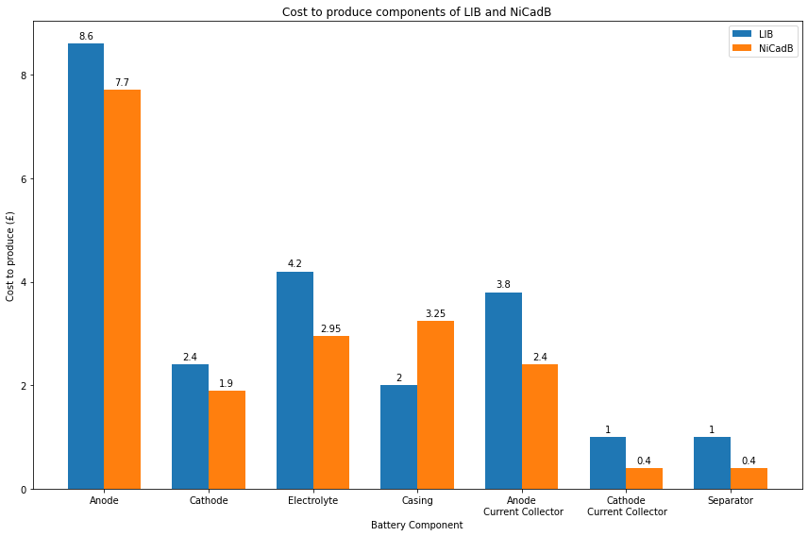**Hypothetical Case Study**

In this assessment, I will examine the operations of a hypothetical Chinese company engaged in battery production. This company imports essential materials such as Lithium and Cadmium. The production process involves material processing, battery production, packaging, and international shipping. Although our primary focus is on laptop batteries, I acknowledge that the company likely also manufactures laptops. However, I will concentrate on the batteries unless additional factors, such as laptop size, are relevant and explicitly stated. To do this, I will use Tesla's Gigafactory as a basis for our company, assuming the factory is 5% the size of the Gigafactory. This assumption accounts for the exclusive production of batteries and acknowledges that the factory is not as large as Tesla's. The data collected includes financial statements from battery-producing companies and articles on factory salaries. Some assumptions were necessary due to the unavailability of specific data, such as land costs in China, which were substituted with data other similar areas. While these assumptions slightly reduce the robustness of the study, they are not crucial to the overall results and thus have minimal impact. All other assumptions were engineering assumptions [25, 48, 49, 50, 51, 52].

**Results and Analysis**

The data aligns with the current landscape of the battery market, where LIBs dominate with a market value of $54.6 billion, compared to $1.4 billion for NiCadBs [2, 25, 53] . This data spans all battery types but considering the near discontinuation of NiCadBs for portable devices, LIBs likely have an even higher market share in the laptop battery segment. This is expected to grow which highlights that a LIB factory would flourish. Project LIB starts with a higher CAPEX and OPEX than Project NiCadB which can be attributed to the high cost of the materials that can be seen in the *LIB CAPEX and OPEX Table*.

Based on this data, we can see that LIBs are a significantly better investment despite their higher CAPEX and OPEX. LIBs provide a higher ROI, a payback period of less than a year, a much greater NPV and consistently generate stable cash flows, ensuring a long business life. On the other hand, NiCadBs start with lower CAPEX and OPEX, which can help a business get started more easily. However, this advantage is offset by their negative return on investment, NPV, cash flow and payback time highlighting that Starting a NiCadB laptop factory is clearly a terrible business choice.

However, the data has a notable inconsistency in the material costs for LIBs, which is reported at £129 million and the ROI being -728% for Project NiCad. These figures are extraordinarily high when compared to both other items in the data and the material costs for NiCadBs which suggests a potential issue with the data accuracy, or the costing methodology used for LIBs.

Upon closer inspection of the *Economic Item Table*, it is evident that these factors are influenced by the volume of batteries sold, with LIBs selling just under 6 million units compared to just under 250,000 units for NiCadBs. This data reflects the current battery market landscape and assumes that if two companies started production now, these would be their annual sales figures, impacting their OPEX and profits, as shown below. While this reflects the current market situation, it does not provide a full comparison assuming both types of batteries were produced and sold in equal quantities. To address this, the study was repeated assuming both types of batteries are produced and sold at 2 million units each. The results indicate that the material costs for LIBs remain higher, but the difference is not as substantial.

Analysing the data now provides a clearer comparison of the batteries and still indicates the previous results of LIBs being a superior investment as to NiCadBs but aren’t as pronounced.

**Social Assessment**

|  |  |  |
| --- | --- | --- |
| Indicators | Units | Reasoning |
| Harm to Locals | N/A | Helps us understand how battery production and usage affect nearby communities. We can look at things like people losing their homes, health problems, or economic troubles. Considering local well-being is important for being socially responsible and sustainable. By looking at these impacts, we can find ways to make battery production and use better for everyone involved. |
| Worker Rights | N/A | It's crucial to assess workers' rights, including their health, to ensure they're well taken care of and not facing physical or mental challenges because of their job. |
| User Experience/  Satisfaction | Out of 10 | Assessing users' experiences with the batteries helps us determine which battery is better suited for use. This improves the overall user experience with the device and can lead to increased adoption of the preferred battery type. |

To collect data for the indicators 'Harm to Locals' and 'Worker Rights,' I focused on both qualitative and quantitative data, ensuring high quality. Articles and reports from those affected by the production and disposal of these batteries were major sources of information, necessitating extensive verification. This included ensuring that reports were from trusted sources, that multiple reports corroborated the topic, and that the voices of those affected were accurately represented without being misconstrued to fit alternative narratives that could undermine their experiences. Challenges arose with the accuracy of some reports, where conflicting narratives were present. In such cases, I prioritised the more reliable reports based on factors such as the credibility of the source, the robustness of the data, and the recency of the information. If reliability could not be ascertained, I discarded conflicting reports to maintain the integrity of the data. For the indicator 'User Experience/Satisfaction,' both quantitative and qualitative data were collected. Qualitative data was converted to quantitative measures where possible. 'User Experience/Satisfaction' incorporated user feelings, emotions, and personal opinions. To gain a more transparent and comparable view, user feedback was converted into ratings. While all indicators inherently lack some degree of accuracy and can be misrepresented due to false or incomplete information, combining multiple indicators provides a more comprehensive understanding of the social aspects of both types of batteries. This multi-faceted approach helps mitigate individual inaccuracies, offering a more balanced and reliable assessment.

**Inventory**

|  |  |  |
| --- | --- | --- |
| **Factor** | **LIB (Chuwi Herobook)** | **NiCadB (Toshiba Tecra 730XCDT)** |
| Battery Life | Average battery life of 8 hours with normal usage. | Average battery life of 3.5 hours with normal usage. |
| Charging Time | Fully charges in approximately 2.5 hours. | Fully charges in approximately 4.5 hours. |
| Heat Generation | Generated minimal heat during operation. During end of use, there was slight heat around touch pad area. | Generated more heat, especially during heavy usage. |
| Safety | High safety standards with built-in protection mechanisms against overheating and overcharging. | Moderate safety standards with a slightly higher risk of leakage or overheating under certain conditions. |
| Long term Performance | Maintained consistent performance over time. | Maintained consistent performance over time. |

|  |  |  |  |  |  |
| --- | --- | --- | --- | --- | --- |
| **Person** | **How would you rate your overall experience using each laptop?**  **(out of 10)** | **Which laptop did you prefer overall?** | **How would you rate the battery life of each laptop during the 30-minute session?**  **(out of 10)** | **Did you notice any significant differences in battery performance between the two laptops?** | **Did you notice any significant differences in laptop heat between the two laptops?** |
| 1 | LIB: 7  NiCadB: 6 | LIB | 5 | No | Yes |
| 2 | LIB: 7  NiCadB: 3 | LIB | 5 | Yes | Yes |
| 3 | LIB: 5  NiCadB: 5 | Neither | 5 | No | Yes |
| 4 | LIB: 8  NiCadB: 7 | LIB | 6 | No | Yes |
| 5 | LIB: 8  NiCadB: 3 | LIB | 8 | No | Yes |
| 6 | LIB: 9  NiCadB: 6 | LIB | 7 | Yes | Yes |

**Harm to Locals**

**LIBs**

The production of lithium, concentrated mainly in South America (Bolivia, Chile, and Argentina) and extending to the United States, Australia, and China, has significant environmental and social impacts. Data for the Manufacture and Disposal stages was not provided by EduPack, and due to limited information from external sources, it was omitted. However, based on the results for other stages and the data available, it can be safely assumed that LIBs generate more CO2 and consume more energy than NiCadBs during these stages.

**Water Scarcity and Contamination:** Lithium extraction involves pumping salty brine from salt flats, consuming approximately 500,000 gallons of water per metric ton of lithium. In Chile’s Salar de Atacama, mining activities have consumed 65% of the region’s water, affecting local farmers and communities. During the evaporation process, contaminants may be released into the environment, potentially harming nearby communities. [55]

**Toxic Chemicals and Health Risks:** In China, toxic chemicals leaked from a lithium mine led to dead fish and contaminated water in the Liqi River. The hydrochloric acid used in lithium processing poses risks to water supplies, and the production process can cause air contamination and soil harm. [56]

**Threat to Indigenous Livelihoods:** Water scarcity caused by mining can threaten the livelihoods of indigenous communities. For example, in Australia’s Salar de Hombre Muerto, residents believe that lithium operations have contaminated streams used for crop irrigation and human consumption. [57]

The impacts of lithium mining extend beyond environmental damage, increasingly affecting local communities by jeopardizing their access to water, a vital resource. This not only harms the locals' livelihoods but also impacts the local flora and fauna. In Chile, mining activities extract and contaminate water sources, rendering them unsuitable for human consumption and leading to water-related conflicts. [58]

**NiCadBs**

Cadmium, a heavy metal used in NiCd batteries, poses significant risks to human health and the environment. Exposure to cadmium can lead to acute poisoning, affecting the digestive system and other organs. Even low levels of cadmium can accumulate in the body over time, potentially causing long-term harm. NiCd batteries involved in fires can release toxic fumes containing nickel, cadmium, and other compounds, further endangering human health. The environmental impact of NiCd batteries is profound. Nickel mining and processing, essential for NiCd battery production, can harm local ecosystems and livelihoods. For instance, fishers in Indonesia have reported damage to fishing grounds due to nickel mining. Additionally, mining for materials used in NiCd batteries often occurs in water-scarce areas, exacerbating local water shortages. This is a significant concern as these activities can lead to water-intensive operations in regions already facing water scarcity. [59, 60]

The significant risks to human health from cadmium exposure underscore the need for sustainable practices which are essential to mitigate the adverse effects on human health

In conclusion, both LIBs and NiCadBs present significant harm to local communities, but NiCadBs appear to be worse in terms of human toxicity and environmental impact. Cadmium exposure from NiCadBs poses severe health risks leading to chronic health issues. While LIBs also have substantial environmental and social impacts, including water scarcity and contamination, the extreme health risks and environmental degradation associated with cadmium in NiCadBs make them more harmful to local communities. Therefore, NiCadBs present greater overall harm to locals compared to LIBs.

**User Experience**

Appendix C outlines variances in usage and underlying rationales between LIBs and NiCadBs, underscoring the necessity of hands-on user experience testing. My investigation comprised two key studies: a personal, fortnight-long comparison of LIB and NiCadB laptops and a collective assessment involving multiple users each spending 30 minutes with the laptops. Understanding user preferences through such analysis holds great importance for manufacturers and consumers alike. This comprehension allows companies to refine their products allowing the development of more sustainable battery options. Nevertheless, it's crucial to acknowledge the limitations of this study, including the potential inaccuracy to fully capture long-term performance disparities, as well as variables like age discrepancies and maintenance history between the two laptops, which might have influenced battery performance. Despite these constraints, the study furnishes invaluable insights into real-world battery usage experiences.

**Results**

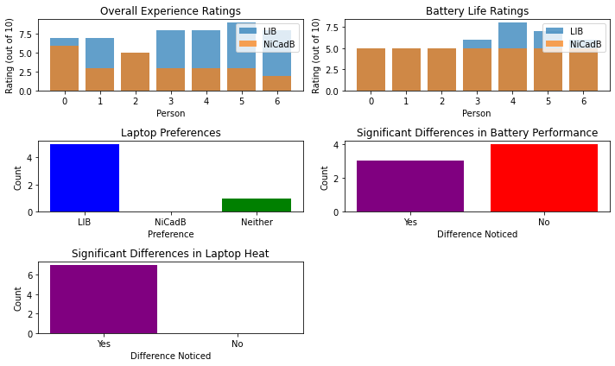

|  |  |  |  |
| --- | --- | --- | --- |
| **Person** | **Question 1**  **Why?** | **Question 2**  **Why?** | **Question 3**  **Why?** |
| 1 | There wasn't much time to use the laptops, so I didn't feel much of a difference | Nicer feel | There wasn't much time to use the laptops, so I didn't feel much of a difference. |
| 2 | The NiCadB laptop was heavier and got hot very quick | Better than the NiCadB laptop | The NiCadB laptop was heavier and got hot very quickly. |
| 3 | Both felt the same to me | Felt the same to me | Both felt the same to me, and their battery life seemed similar during the short session. |
| 4 | The LIB laptop was better to hold | It was better to hold and use | The LIB laptop was better to hold, and its battery life seemed more consistent during use. |
| 5 | The NiCadB laptop got hot and lost charge very quickly. The LIB laptop was much better in comparison | Much better than the other laptop | Both were alright to use but the NiCadB laptop was worse in every way, including battery performance, as it drained faster. |
| 6 | Both were alright to use but the NiCadB laptop was worse in every way | Better than the other laptop | Both were alright to use but the NiCadB laptop was worse in every way, including battery performance, as it drained faster. |
| 7 | The LIB laptop was easier to hold and had good charge life compared to the NiCadB laptop. | Nice to hold and use with good charging | The LIB laptop was easier to hold and had good charge life compared to the NiCadB laptop, which depleted quickly. |

**Analysis**

|  |  |
| --- | --- |
| **Overall Experience Ratings:** | The analysis of user ratings indicates that the LIB laptop consistently outperforms the NiCadB laptop in overall user experience. The LIB laptop never received a lower rating than the NiCadB laptop from any user. This trend shows a strong preference for the LIB laptop in terms of user satisfaction. |
| **Battery Life Ratings:** | The battery life ratings for the LIB laptop are generally higher, though the margin is smaller compared to the overall experience ratings. This suggests that while the LIB laptop is preferred, the NiCadB laptop’s battery life is considered adequate by some users, though not as good as the LIB laptop. |
| **Laptop Preferences:** | In terms of laptop preferences, many users favored the LIB laptop. No participants preferred the NiCadB laptop, and only one user expressed no preference for either laptop. This clear preference further underscores the LIB laptop’s superiority in user satisfaction. |
| **Significant Differences in Battery Performance:** | The data reveals a split perception regarding battery performance differences, with users almost evenly divided on whether they noticed significant differences. This indicates that while the overall ratings favor the LIB laptop, some users found the NiCadB laptop’s battery performance comparable during the test period. |
| **Significant Differences in Laptop Heat:** | All users noticed significant differences in heat emission, with the NiCadB laptop consistently noted for higher heat output. This unanimous observation highlights a critical drawback of the NiCadB laptop, as excessive heat can affect user comfort and the device's longevity. |

The comprehensive analysis combining both quantitative and qualitative data highlights a clear preference for the LIB laptop over the NiCadB laptop. The LIB laptop is favored for its better overall user experience, superior battery life, and lower heat emission. While some users noted similar battery performance between the two laptops in a short session, the NiCadB laptop’s higher heat output and quicker battery depletion are significant drawbacks. This analysis suggests that the LIB laptop is a better choice for users seeking better performance and comfort, although the NiCadB laptop remains viable for less demanding applications. Addressing heat management in NiCadBs could improve their viability, but as it stands, the LIB laptop is the superior option in this comparison.

**Discussion and Interpretation**

**Environmental Comparison**

LIBs generally emit less CO2 than NiCadBs throughout their lifecycle, except during transportation due to their higher popularity, resulting in more overall CO2 pollution. Despite this, LIBs are still the more sustainable choice. Similarly, LIBs are more energy-efficient overall, although transportation may skew this comparison. While LIBs use more water due to lithium extraction, the additional materials in NiCadBs balance out water consumption. Though the assessment has some limitations, it offers accurate insights for further review. In terms of toxicity, LIBs are less hazardous than NiCadBs, with cadmium posing greater risks. Enhanced lithium recycling and longer lifecycles make LIBs environmentally friendlier and less toxic.

**Economic Comparison**

Despite their higher production costs, LIBs emerge as a more sustainable and economically viable choice over NiCadBs. The elevated material expenses for LIBs, driven by lithium's cost and extraction efforts, are offset by their superior performance, market demand, and environmental benefits. Economically, LIBs offer better returns, shorter payback periods, and greater net present value compared to NiCadBs. Despite NiCadBs' lower initial costs, their negative ROI and prolonged payback time make them less attractive.

**Social Comparison**

LIBs are superior to NiCadBs in terms of user experience and harm to locals. Users consistently rated the LIB laptop higher in overall experience and battery life, preferring it for its lighter weight and cooler operation. In terms of social impact, NiCadBs pose greater harm to locals due to cadmium's toxicity, which can lead to significant health and environmental issues. Conversely, while LIB production involves water-intensive processes, the social and environmental harm from cadmium in NiCadBs is more severe, making LIBs the better choice overall.

**Limitations, Changes, and Improvements**

This LCA faced limitations due to scarce data on NiCad battery materials and the complex nature of battery technology. These constraints impacted result accuracy, with key assumptions made due to data gaps. Improvements in data collection could enhance accuracy, informing better decisions in battery design, recycling, and environmental impact assessment.

To improve cost efficiency and reduce environmental impact in battery production, prioritising mining lithium close to production to reduce travel can help reduce CO2 emissions, cost, and Energy Usage.

**Conclusion and further work**

In this LCA I conducted an Environmental, Economic and Social Assessment on LIBs and NiCadBs for laptops to assess which battery was more sustainable environmentally, was a better investment and what had less social harm. This assessment allowed me to deduce that LIBs are largely superior to NiCadBs for this criterion.

[13] Large Power. (2022). *Battery Technology - Past, Present, and Future*. <https://www.large.net/news/93u43n6.html>

**Appendix**

# **A**

## **How do the Batteries work**

Lithium-ion (Li-ion) and nickel-cadmium (NiCd) batteries operate based on different electrochemical principles, but they both rely on the movement of ions between the anode and cathode to generate an electrical current.

LIBs are composed of several key components:

1. Anode (negative electrode): Typically made of graphite, which can store and release lithium ions during charging and discharging.
2. Cathode (positive electrode): Commonly made of lithium metal oxides like lithium cobalt oxide (LiCoO2), which can accept and release lithium ions.
3. Electrolyte: A lithium salt solution (e.g., lithium hexafluorophosphate, LiPF6) in an organic solvent, allowing the flow of lithium ions between the electrodes.
4. Separator: A microporous polymer membrane that separates the anode and cathode while allowing lithium ions to pass through.

During discharge, lithium ions move from the anode through the electrolyte and separator to the cathode, while electrons flow through the external circuit, generating an electrical current. During charging, the process is reversed, with lithium ions moving back to the anode and being stored in the graphite structure.

NiCadBs have a similar structure but utilise varied materials and reactions:

1. Anode (negative electrode): Made of cadmium hydroxide (Cd (OH)2), which can store and release electrons during discharge and charging.
2. Cathode (positive electrode): Composed of nickel oxyhydroxide (NiOOH), which can accept and release electrons.
3. Electrolyte: An alkaline solution, typically potassium hydroxide (KOH), which allows the flow of hydroxide ions (OH-) between the electrodes.

During discharge, cadmium ions from the anode combine with hydroxide ions from the electrolyte to form cadmium hydroxide (Cd (OH)2), while nickel oxyhydroxide at the cathode is reduced to nickel hydroxide (Ni (OH)2), generating an electrical current. During charging, this process is reversed, with cadmium hydroxide being oxidized back to cadmium and nickel hydroxide being oxidized to nickel oxyhydroxide.

Both Li-ion and NiCd batteries rely on reversible electrochemical reactions, which allow them to be recharged and used multiple times. However, Li-ion batteries have higher energy density, longer lifespan, and lower environmental impact compared to NiCd batteries, which contain toxic cadmium and have been phased out in favour of Li-ion and other battery technologies. [7] [30]

# **B**

# **How Lithium is mined**

Lithium extraction is a set of chemical processes where lithium is isolated from a sample and converted into a saleable form, typically lithium carbonate. As lithium is highly reactive, it is not found in nature as a pure element but rather as a constituent of salts or compounds.

The two major sources of commercial lithium are:

1. Underground Brine Deposits

* Found beneath salt flats (salars) in South America and China.
* Also includes geothermal and oil field brines.

2. Mineral Ore Deposits

* Spodumene is the most common lithium-bearing mineral, followed by lepidolite, petalite, amblygonite, and eucryptite.

Extraction Methods

1. Conventional Lithium Brine Extraction

* Brine is pumped from underground deposits to evaporation ponds.
* Solar evaporation concentrates the lithium content over months or years.
* Concentrated brine undergoes filtration, chemical treatment, and precipitation to produce lithium carbonate.

2. Hard Rock/Spodumene Lithium Extraction

* Mineral ore is mined from hard rock formations.
* Ore is crushed, heated, and chemically treated to extract lithium.
* Energy-intensive process, making it costlier than brine extraction.

Other Potential Sources

* Hectorite clay (still uneconomical)
* Seawater (emerging membrane technologies show promise)
* Recycled brines from energy plants
* Recovered oil field brine
* Recycled lithium-ion batteries

While these sources are being explored, salar brine mining and mineral ore mining remain the most economically viable options for lithium extraction currently. [31]

**C**

The main drawback of NiCadBs is that they suffer from a "memory effect" which is not present in LIBs. When discharged and recharged to the same state many times, the battery "remembers" where recharging began in the cycle. During subsequent use, the voltage drops to that point, as if the battery had been discharged making the battery appear dead much earlier than normal.

Repeated overcharging causes voltage depression or "lazy battery effect," where the battery seems fully charged but quickly discharges. With proper care, a nickel-cadmium battery can last for over 1,000 cycles before capacity drops below half. Reverse charging, often due to user error or full discharge in multi-cell batteries, can decrease battery life and produce dangerous hydrogen gas as a by-product. NiCad batteries left unused may develop dendrites, conductive crystals that penetrate electrode separators, causing internal short circuits and premature failure.

LIBs can be recharged before they are fully discharged without creating a “memory effect” and compared to Ni-Cd, the self-discharge in lithium-ion is less than half. LIBs are smaller, lighter, more compact and provide more energy. The only drawback is lithium-ion battery is fragile and requires a protection circuit to maintain safe operation. The protection circuit is built into each pack, which limits the peak voltage of each cell during charge and prevents the cell voltage from dropping too low on discharge. To prevent temperature extremes the cell temperature is also monitored. [30, 34]